**PART A**

**EXPERIMENT NO. 4**

**A.1 AIM: - Modeling UML Class diagrams.**

**A.2 Prerequisite**

**1. Concepts of Actor, Use Case and Relationships**

**A.3 Outcome**

After successful completion of this experiment students will be able to

Design solution using unified modeling language.

**A.4 Task:**

For the problem statement in Handout attached,

1. Write CRC card.

2. Complete Class Diagram in StarUML.

**PART B**

(PART B: TO BE COMPLETED BY STUDENTS)

*(Students must submit the soft copy as per the following segments within two hours of the practicals. The soft copy must be uploaded on Blackboard LMS or emailed to the concerned Lab in charge Faculties at the end of practical; in case Blackboard is not accessible)*

|  |  |
| --- | --- |
| Roll No: C101 | Name: Samkeet Shah |
| Class: C | Batch: B3 |
| Date of Experiment: | Date of Submission: |
| Grade: |  |

**B.1 Actors:**

1. Users
2. DSNM Application
3. E-Challan Website
4. Payment Gateway

**B.2 Class Diagram:**

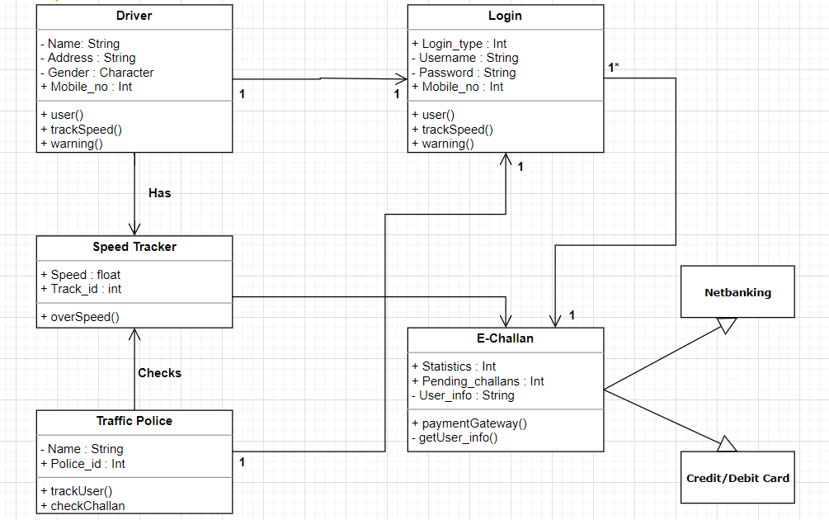

**B.3 Conclusion**

Understood the concepts related to designing the Class Diagrams and how to implement them with reference to the selected project